广安市二O一O年高中阶段教育学校招生考试
英 语 试 卷
注意事项：1．全卷共12页，满分150分，由卷I（100分）和卷II（50分）组成，答题时间为120分钟。
2．请考生将自己的姓名、考号填涂到机读卡和卷II相应位置上。
3．请考生将卷I的答案转涂到机读卡相应位置，卷II的答案直接写在试卷上。
卷I （共三部分；满分100分）
第一部分 听力（共两节；满分25分）
第一节：（共10小题；每小题1分，满分10分）
听下面10段对话。每段对话后有一个小题，从题后所给的A、B、C三个选项中选出最佳答案，并将答案转涂到机读卡上相应的位置。听完每段对话后，你有10秒钟的时间来回答有关小题和阅读下一小题。每个对话读两遍。
1. What are the children doing?
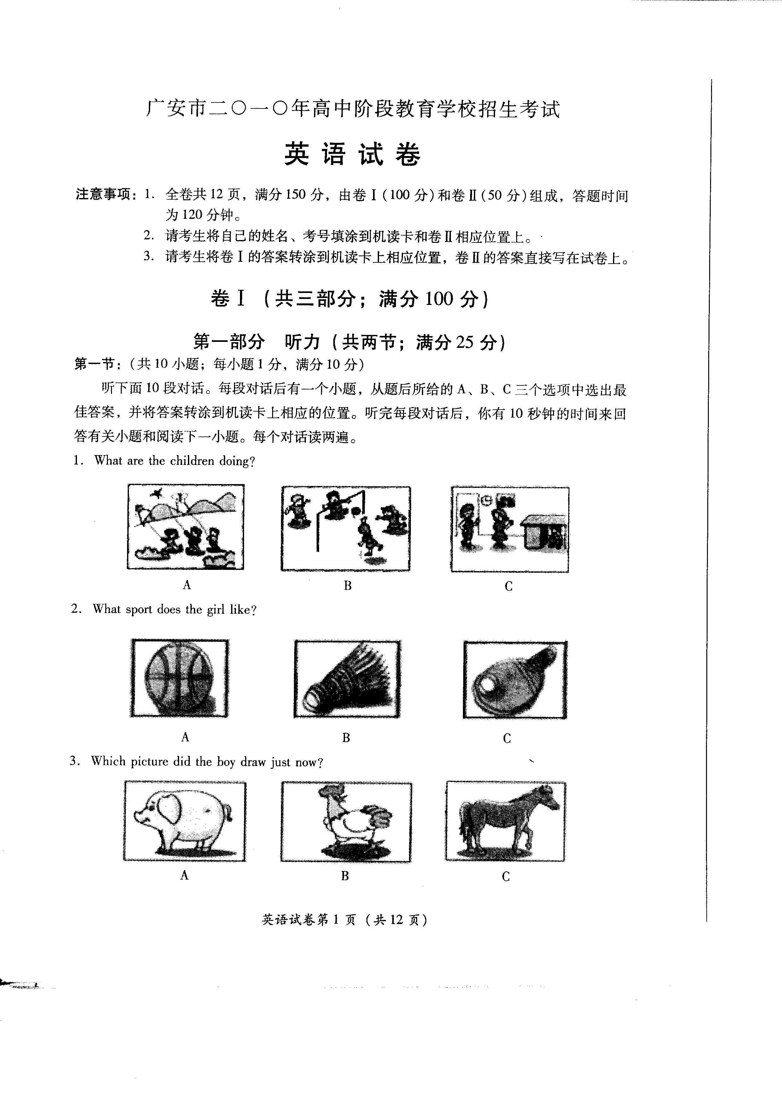
A B C
2. What sport does the girl like?
A B C
3. Which picture did the boy draw just now?
A B C
4. Who can’t find her mother?
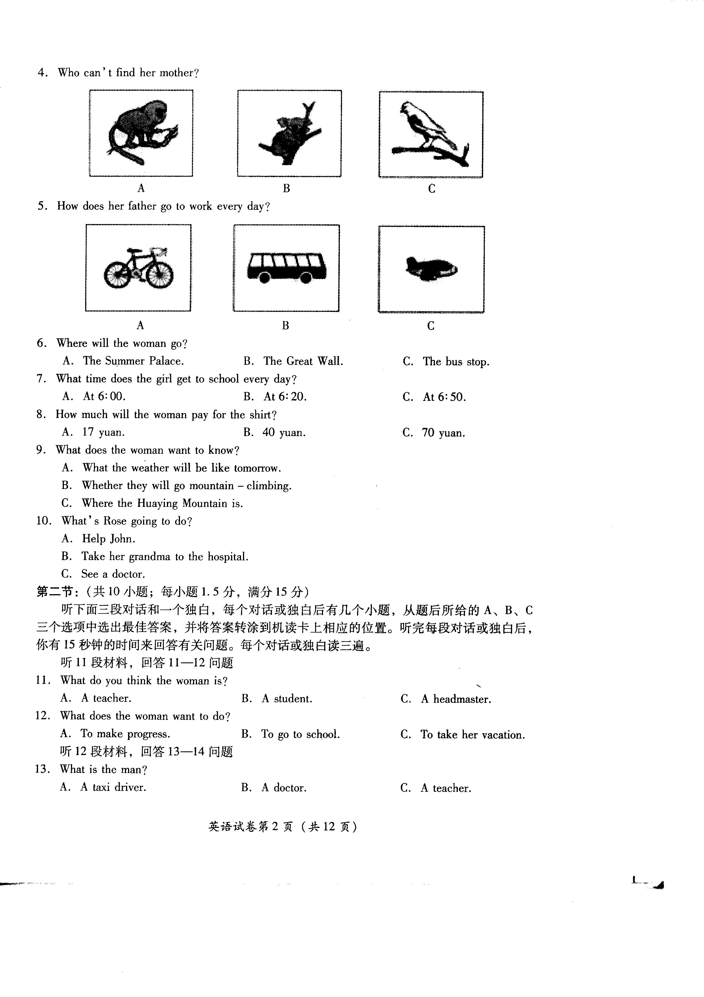
A B C
5. How does her father go to work every day?
A B C
6. Where will the woman go?
A. The Summer Palace. B. The Great Wall. C. The bus stop.
7. What time does the girl get to school every day?
A. At 6:00. B. At 6:20. C. At 6:50.
8. How much will the woman pay for the shirt?
A. 17 yuan. B. 40 yuan. C. 70 yuan.
9. What dows the woman want to know?
A. What the weather will be like tomorrow.
B. Whether they will go mountain climbing.
C. Where the Huaying Mountain is.
10. What’s Rose going to do?
A. Help John. B. Take her grandma to the hospital. C. See a doctor.
第二节：（共10小题；每小题1.5分，满分15分）
听下面三段对话一个独白，每个对话或独白后有几个小题，从题后所给的A、B、C三个选项中选出最佳答案，并将答案转涂到机读卡上相应的位置。听完每段对话或独白后，你有15秒钟的时间来回答有关问题。每个对话或独白读三遍。
听11段材料，回答11-12问题
11. What do you think the woman is?
A. A teacher. B. A student. C. A headmaster.
12. What does the woman want to do?
A. To make progress. B. To go to school. C. To take her vacation.
13. What is the man?
A. A taxi driver. B. A doctor. C. A teacher.
14. How long does it take them to get to the hospital?
A. Ten minutes. B. Half an hour. C. Two hours.
听13段材料，回答15-16问题
15. What color is the bag?
A. Yellow. B. Black. C. Blue.
16. Was the bag found?
A. Yes, it was. B. No, it wasn’t. C. I don’t know.
听14段材料，回答17-20问题
17. Where can we find water?
A. We can find water only in rivers and seas.
B. We can find water only in the air.
C. We can find water almost everywhere.
18. Is water needed everywhere?
A. Yes, it is. B. No, it isn’t. C. We don’t know.
19. What are clouds made of?
A. Seas, rivers and lakes. B. Snow and ice. C. Very small drops of water.
20. What is the best title of the passage?
A. Water in river. B. Man needs water. C. The importance of water.
第二部分 基础知识运用（共两节；满分35分）
第一节：单项填空（共20小题；每小题1分，满分20分）
从A、B、C三个选项中选出可以填入空白处的最佳选项。
21. —When were you born? —I was born ______ November 6th, 1996.
A. in B. on C. at
22. —Do you know Meimei? —Yes, she is from a university and she is ______ honest girl.
A. a B. an C. /
23. —Study hard, ______ you won’t pass the exam. —I see, Mum.
A. or B. and C. but
24. —Jenny, is this ______ bike? —Oh, no, it’s not ______.
A. your; mine B. you; my C. yours; my
25. —Excuse me, can you tell me the way to the zoo?
—Sorry, I’m new here. Please ask that policeman. He ______ know.
A. can B. need C. may
26. —How far is your home from school? —It’s about two ______ walk.
A. hour’s B. hours C. hours’
27. —How tall he is! —Yes, he is ______ than any other student in his class.
A. tall B. taller D. tallest
28. —You’ve done a nice job! —Thanks. I always do everything ______.
A. care B. careful C. carefully
29. —I’m going to have a summer holiday in Dalian. —______
A. Have a good time. B. No, it’s bad. C. That’s all right.
30. —Which is the second day of a week? —______, if course.
A. Monday B. Tuesday C. Wednesday
31. —Your English is pretty good! How about ______ some advice to me? —With pleasure.
A. give B. gives C. giving
32. —Please remember ______ the lights when you leave the room. —OK, I will.
A. turn off B. to turn off C. turning off
33. —______ do you water the plants, Miss Yang? —Twice a day.
A. How much B. How soon C. How often
34. —Do you have this kind of MP5? —Sorry, we ______ yesterday. You can come next week.
A. tried them on B. took them off C. sold them out
35. —There is ______ with my leg. —Don’t worry. Let me help you.
A. nothing wrong B. something wrong C. wrong something
36. —I want to know ______. —Let me show you the way.
A. where I can buy books B. where can I buy books C. where books can I buy
37. —When did the old man die? —In 2007. He ______ for nearly three years.
A. died B. has died C. has been dead
38. —What will Lucy do this Sunday?
—She as well as her family ______ go camping by a small lake.
A. am going to B. is going to C. are going to
39. —I want to know if Mr. Green will come here tomorrow. —If he ______, I’ll tell you.
A. come B. comes C. will come
40. —Do you know when the 29th Olympic Games ______? —Yes, in 2008.
A. hold B. is held C. was held
第二节：完形填空（共15小题；每小题1分，满分15分）
先通读下面的短文，读懂大意，然后从后面各题所给的A、B、C三个选项中选择可以填入相应空白处的最佳选项。
（A）
One day a woman got into her car and started driving home after work. Suddenly, she saw a yellow car behind her. The 41 was a man. Wherever she drove, the young man followed her. When she 42 at the traffic lights, the yellow car stopped behind her.
The woman was afraid, so she drove 43 to the police station. She was very 44 when she found the car stopped behind her. At that time, she saw a woman outside the police station. She knew that she was a policewoman because she was wearing a police uniform. She jumped out 45 her car and ran to her. But the young man just smiled and came up to return the purse which was dropped on the street by the woman.
41. A. worker B. drover C. passenger
42. A. stop B. stops C. stopped
43. A. quickly B. easily C. happily
44. A. interested B. moved C. surprised
45. A. at B. on C. of
（B）
Long long ago, there was a man whose name was Frank. He loved his 46 very much. A special day was coming. It was his wife’s birthday. Frank decided 47 something for her.
The next day he 48 home and said to his wife, “I bought something 49 you.” “Thank you!” said his wife 50 . “What have you bought for me?” “I’ve bought a gold ring. Here it is.” He took it out for his wife to see. Carelessly, he dropped it onto the ground. He began to look for it on the ground, 51 it was dark in the house and he could not see 52 . Then he went out and began to look for it in the street.
He looked and looked. After a while, a friend came along. “What’s the matter with you?” asked his friend. “I am 53 for my ring. It was for my wife. But I lost it just now.” said the poor man. “ 54 did you lose it?” “I lost it in my house.” “You lost your ring in your house, but you are looking for it in the street. How foolish you are!” “Ah,” said the man, “but it is dark in my house. I will never find it there. Anyhow, here in the street, it is much 55 . I can see everything more clearly.” My dear friend, do you think Frank could find his gold ring in the street?
46. A. wife B. daughter C. son
47. A. to show B. to buy C. to cook
48. A. go B. goes C. went
49. A. for B. with C. to
50. A. angrily B. sadly C. happily
51. A. but B. so C. because
52. A. something B. anything C. nothing
53. A. asking B. calling C. looking
54. A. Where B. When C. Why
55. A. darker B. brighter C. harder
第三部分 阅读理解（共20小题；每小题2分，满分40分）
阅读下列短文，从各题所给的A、B、C三个选项中，选出最佳选项。
（A）
We can find ads everywhere. Here are four ads. Please read them carefully.
（1）WAITE WANTED  Are you hard—working? Do you like to meet people? If your answer is “Yes”, then we have a job for you as a waiter. Call AL Hotel at 8556779. | （2）REPORTER WANTED  Do you like to talk with people? Do you like to write stories? If you want to work for our magazine as a reporter, please call Karen at 8558366.
（3）HELP WANTED  Do you like babies? Can you look after one baby for two days? If you are sure to take good care of it, call us at 8766588. $ 80 or more. Today! Hurry1 | （4）CLEANER WANTED  Can you make a large house clean and tidy? If you hope to get the job paid at $ 20 once, call us this evening 18:00—20:00. Tel: 8633800.
56. ______ are needed in AL Hotel.
A. Cleaners B. Reporters C. Waiters
57. If you like children and have two — day free, you can call at ______ for a job.
A. 8556779 B. 8558336 C. 8766588
58. If the owner of the large house asks a cleaner to tidy his house once a day, how much will the cleaner get in a week?
A. $ 120. B. $ 140. C. $ 160.
59. If you’re a college student of English who enjoys writing, during your summer holidays you will be more interested in the job in ______.
A. ad（1） B. ad（2） C. ad（3）
60. The above job ads are probably from ______.
A. a science book B. a story book C. a newspaper
（B）
Last weekend, when Jack was walking in the park, he saw a woman, who lived a few miles away, sitting on a bench with a dog beside her. The dog was looking up at the woman.
Jack walked up to the woman and said, “Hello, Sue, how are you? May I sit and talk with you for a while?”
“Of course, please sit down,” Sue said.
Jack sat down next to Sue on the bench, and they talked quietly together. The dog continued to look up at Sue, as if waiting to be fed. “That’s a nice dog, isn’t he?” Jack said, pointing at the animal.
“Yes, he is. He’s handsome. He’s a bit of a mixture, but that’s not a bad thing. He’s strong and healthy.”
“And hungry,” Jack said. “He hasn’t taken his eyes off you. He thinks you’ve got some food for him.”
“That’s true,” Sue said. “But I haven’t.”
They both laughed and then Jack said, “Does your dog bite?”
“No,” Sue said. “He’s never bitten anyone. He’s always gentle and friendly.”
Hearing this, Jack decided to hold out his hand and touched the animal’s head. Suddenly it jumped up and bit him.
“Hey!” Jack shouted. “You said your dog didn’t bite.”
Sue replied in surprise. “Yeah, I did. But this is not my dog. My dog’s at home.”
61. Jack and Sue were ______.
A. friends B. next—door neighbours C. strangers
62. The dog looked at the woman because ______.
A. the woman wanted to feed him B. the woman was friendly C. it was hungry
63. Jack touched to dog because he believed ______.
A. the dog was handsome B. Sue’s dog was unfriendly C. the dog belonged to Sue
64. Do Sue’s dog bite?
A. Yes, it does. B. No, it doesn’t. C. We don’t know.
65. Which of the following can be the best title of the passage?
A. A Wrong Question B. Sue’s Dog C. A Pleasant Meeting
（C）
There are differences between western culture and Chinese culture. We can see differences when we pay attention to the way words are used. Let’s look at the words about animals and plants. Most expressions in Chinese is about the dog, for example, “a homeless dog”, “a mad dog”, “a running dog” and “a dog catching a mouse”, have negative(消极) meanings. But in western countries, dogs are thought to be honest and good friends of humans. In English, people use the dog to describe positive(积极的) actions. For example, “you are a lucky dog” means you are a lucky person. And “every dog has its day” means each person has good luck sometimes. To describe a person’s serious illness, they say “sick as a dog”. The word “dog—tired” means very tired. However, Chinese love cats very much. But in western culture, “cat” is often used to describe a woman who is cruel(冷酷的). There are many other examples of how “cat” is used differently as well.
The rose is regarded as a symbol of love in both China and some western countries. People think the rose stands for love, peace, courage and friendship. And the rose is the national flower of England, America and many other countries.
The words about plants and animals are used in positive or negative ways in different cultures. We can learn about many differences in cultures by comparing how some words are used.
66. The word “dog” in Chinese usually ______.
A. stands for friendship B. has a negative meaning C. has a positive meaning
67. “Every dog has its day.” means “______”
A. Everybody in the world is lucky. B. Each person lives his own way of life.
C. Everybody has a time in life to be lucky.
68. Western people usually use “cat” to refer to “______”.
A. a tired person B. a brave man C. an unkind woman
69. Which of the following is TRUE according to the passage?
A. Words show differences in cultures.
B. Western people think cats to be good friends.
C. Rose is the national flower of all western countries.
70. This passage mainly tells us ______.
A. negative or positive things B. different countries have different cultures
C. what dog and cat mean in English and Chinese
（D）
Many children use the Internet to get useful knowledge and information, and to relax in their free time. But some of them are not using it is a good way. Here are some rules to make sure you are safe and have fun on the Internet.
Make rules for Internet use with your parents. For example, when you can go online, for how long and what activities you can go online.
Don’t give your password(密码) to anyone else, and never give out the following information—your real name, home address, age, school, phone number or other personal information.
Check with your parents before giving out a credit card(信用卡) number.
Never send a photo of yourself to someone by e－mail unless your parents say it’s OK.
Check with your parents before going into a chat room. Different chat rooms have different rules and attract different kinds of people. You and your parents ought to make sure it’s a right place for you.
Never agree to meet someone you met on the Internet without your parents’ permission(允许). Never meet anyone you met online alone.
Always remember that people online may not be who they say they are. Treat everyone online as strangers.
If something you see or read online makes you uncomfortable, leave the site. Tell a parent or teacher right away.
Treat other people as you’d like to be treated. Never use bad language.
Remember — not everything you read on the Internet is true.
71. It’s good for children to ______ on the Internet.
A. give password to others B. get useful knowledge and information
C. give out a credit card number
72. The writer tells children to ______.
A. send their photos to him B. make rules for Internet use with parents
C. believe everything they read on the Internet
73. According to the passage, if your parents don’t agree, never ______.
A. read anything on the Internet B. relax in your free time
C. have a face－to－face meeting with anyone you met online
74. What should NOT be done when you are on line?
A. Using bad language. B. Leaving the site if you feel uncomfortable.
C. Treating everyone online as strangers.
75. The main idea of this passage is about ______.
A. how to use computers B. information on the Internet C. Internet safety rules

广安市二O一O年高中阶段教育学校招生考试
英 语 试 卷
卷II （共四部分；满分50分）
题号 | 第一部分 | 第二部分 | 第三部分 | 第四部分 | 总分 | 总分人
分数
注意事项：1．答题前请将密封线内的项目填写清楚；

_________________区、市、县 校，姓名 准考证号◻◻◻◻◻◻◻
密 封 线 内 不 要 答 题
装订线
2．请将卷I正确选项填在机读卡上相应的位置；
3．卷II共4页，请用蓝、黑墨水笔将答案直接写在试卷上。

第一部分 口语运用（共10小题；每小题1分，满分10分）

得分 | 评卷人 | 从对话后的选项中选择适当的选项补全对话，把相应的字母番号填在方框下面的横线上
（A）
Mr. Green：Hello! This is English－help Centre. 1
Li Lei：Yes. I have some problems with English.
Mr. Green： 2
Li Lei：First, I can’t speak English well.
Mr. Green： 3 Why not join a language club to practice English?
Li Lei：OK, I’ll try it. Also I can’t understand the teacher when she talks to the class.
Mr. Green：Listening to more tapes will help a lot. Remembering the words of English songs also helps a lot.
Li Lei： 4 I’ll do that as much as possible.
Mr. Green：You’re welcome. 5
A. Don’t worry.
B. I hope your English will improve soon.
C. Can I help you?
D. Thank you very much.
E. What are your problems?
1.____________ 2.____________ 3.____________ 4.____________ 5.____________
（B）
Tony：Hi, Joy. Would you like to help to save the environment?
Joy： 6 What can I do?
Tony：Well, first, you can start by turning off the lights.
Joy：Yes. That’s easy. Sometimes I turn on the lights without thinking. What’s next?
Tony：Second, listen. 7 Don’t take a bus or a taxi if you don’t have to.
Joy：That will save money, too. 8
Tony： 9
Joy：Mm, newspapers, magazines, mails … We get a lot of paper at home. Good idea.
Tony：And last, take a bag when you go shopping. 10
Joy：OK. My parents do most of the shopping. I’ll tell them.
A. You can ride a bike.
B. I don’t know.
C. Don’t use plastic bags.
D. What else?
E. Try to recycle paper.
6.____________ 7.____________ 8.____________ 9.____________ 10.____________
第二部分 单词拼写（共15空；每空1分，满分15分）
得分 | 评卷人 | A．根据汉语提示，用单词的正确形式填空，每空一词。（共7小题；每小题1分，满分7分）
1. Mr. Wang Lives on the ______________________ (第五) floor.
2. My mother is ______________________ (忙) cooking in the kitchen.
3. Look! There are lots of ______________________ (绵羊) on the farm.
4. We shouldn’t ______________________ (依靠) too much on our parents.
5. Many ______________________ (机器人) will do heavy work for us in the future.
6. I asked her if she was ready to go, and she ______________________ (点头) her head.
7. It’s pleasant to visit Alaska in ______________________ (八月) but it might be cool in the evening.
得分 | 评卷人 | B．短文填空（共8小题；每小题1分，满分8分）根据短文内容和首字母提示，把所缺单词填写在短文中相应的横线上，使句意完整。
One day two young men went to the forest. On the way, one said t the other, “We’re g friends. We must help each o ” “All right!” the other one answered. After a short t , there was a great noise. It was a big bear. The two men ran a quickly. One of them got up into a tree. The other was fat and couldn’t c up. He threw himself at the foot of the tree. The bear came near. It looked at the fat man, put i nose down and smelt him. It thought the young man was dead, so it walked away. The man in the tree came down. He asked his friend, “The bear put its mouth so near to your ear. W did it say to you?” The fat young man answered, “the bear said, ‘A friend in need is a friend indeed.’ ”
第三部分 短文改错（共10小题；每小题1分，满分10分）
得分 | 评卷人 | 下面短文中的划线部分是错误的，请改正，不得改变原文意思，并将正确答案写在右边相应题号的横线上。
I live in the country and my father was a farmer. 1._____________________
He is now forty－five year old. Because of years of 2._____________________
hard work, he looks old than his age. When I was 3._____________________
young, he used to tell me the important of study. 4._____________________
Father knows few about English and other subjects, 5._____________________
but he usually gives me any good advice on how 6._____________________
to learn my lessons good. He is not only kind to me 7._____________________
but also very strict in me. With his help, I’ve made 8._____________________
great progress. I’ll never forget what him taught 9._____________________
me. I think my father is a best father in the world. 10.____________________
第四部分 书面表达（满分15分）
得分 | 评卷人 | 近来，全国正在进行平安校园建设，我市也不例外。作为一名学生，我们更应该珍惜自己的生命，更应该注意自己的人身安全。假如你是Daming，并担任校学生会主席，请你就安全问题，向全校学生发出倡议，写一封安全倡议书。
内容提示：（1）不带管制刀具到学校；
（2）不私自下河洗澡；
（3）不打架；
（4）上学放学的途中应该注意安全；
（5）遇紧急情况，立即报告警察或老师。
……
参考词汇：管制刀具：restricted knives or things；洗澡：have a bath；打架：fight；紧急情况：emergency；交通安全：pay attention to the traffic。
写作要求：（1）用词恰当，要点全面，层次清晰，书写规范。
（2）可适当发挥，80词左右，开头、结尾已给出，不计入总词数。
（3）严禁出现自己的真实姓名和学校等相关信息。
Dear students,
As we know, safety is the most important thing in our lives. So, we should try our best to make sure we are safe. _____________________________________________________________________
______________________________________________________________________________________________________________________________________________________________________________________________________________________________________________________________________________________________________________________________________________________________________________________________________________________________________________________________________________________________________________________________________________________________________________________________________________________________________________________________________________________________________________________________________________________________________________________________________________________________________________________________
Yours,
Daming



