哈尔滨市2010年初中升学考试
英语试卷
考生须知：
1．本试卷满分为120分，考试时间为100分钟。
2．答题前，考生先将自己的“姓名”、“准考证号码”在答题卡上填写清楚，将条形码准确粘贴在条形码区域内。
3．考生作答时，请按照题号顺序在答题卡各题目的区域内作答，超出答题卡区域书写的答案无效；在草稿纸、试题纸上答题无效。
4．选择题必须用2B铅笔在答题卡上填涂，非选择题用黑色字迹书写笔在答题卡上作答。否则无效。
5．保持卡面清洁，不要_折L叠--、不要弄破、弄皱，不准使用涂改液、修正带、刮纸刀。
第 I 卷
一、听力测试(本题共30分)听录音，每题读两遍。
I．听句子，选出与所听句子内容相匹配的图画。(本题共5分，每小题1分)
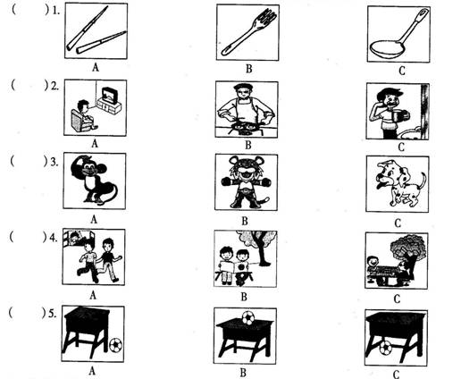
Ⅱ．听对话，根据问题选出正确答案。(本题共10分，每小题2分)
( )6．．She has a cold． B．She wants to eat something．
C．She has a headache．
( )7．A．Because the music there is loud． B．Because it's the cheapest．
C．Because it’s the nearest．
( )8．A．To a flower show． B．To a talent show．
C．To a magic show．
( )9．A．A pear． B．An apple． C．A banana．
( )10．A．In Paris． B．In London． C．In Macao．
Ⅲ．听对话。根据对话内容选出最佳答案完成各句。(本题共5分，每小题1分)
( )11．The weather in Beijing will be ______ tomorrow．
A．snowy B．sunny C．windy
( )12．There is a lot of ______ in winter in Beijing．
A．ice B．snow C．wind
( )13．______ seasons are mentioned in the conversation．
A．One B．Two C．Three
( )14．Though winds sometimes blow strongly in ______，it is quite warm．
A．winter B．summer C．spring
( )15．The woman prefers winter because ______.
A．she can play with snow B．it is cold C．she can skate
IV．听短文，根据所听内容选出短文中划线部分词的同义词或同义短语。(本题共10分，每小题2分)
John wants a bike．He asks his 16 for the money and they say he must make it 17 ．But how? He thinks about this problem on his way home．Suddenly，he has all idea．Dick，one of his classmates，is delivering(速递) newspapers 18 ．“Yes, I can do that!”John is so happy．“ 19 l can get my own bike very soon．I can pay a little money for it 20 week．"Then he goes to ask Dick lots of questions about his job．He finds out that he can get twenty-five dollars each week，and he only needs to work about three hours each night．When he knows the telephone number of the newspaper，he runs back home and tells his mother about it．His mother says，“I think it’s a good idea．I’ll call，the newspaper．”“No，Mum．I’11 call．I’m going to be a businessman．”says John．
( )16．A．parent B．parents C．grandparents
( )17．A．alone B．lonely C．on your own
( )18．A．in the old days B．at that time C．recently
( )19．A．Perhaps B．Whenever C．Whether
( )20．A．all B．either C．every
二、单项选择(本题共15分，每小题1分)选择最佳答案。
( )21．Every one of you is looking forward ______ getting a good result．Better think carefully before writing down your answers．Wish you success!
A．on B．in C．to
( )22．A low-carbon(低碳)lifestyle has ______ effect on our daily life．People are paying more and more attention to saving ______ these days．
A．the；energies B．a；energy C．an；energy
( )23．Two places of interest in Beijing nee well-known to people from home and abroad．One is the Great Wall，______ is the Summer Palace．
A．the other B．another C．other
( )24．一There are always many volunteers in great events, ______?
一Yes．Many hands make light work!
A．aren’t there B．are there C．area’t they
( )25．The FWA World Cup is ______ fantastic that a lot of people in the world aye crazy(疯狂的) about it．
A．such B．so C．very
( )26．Great changes have taken place since we ______ E—Times．And the computer is widely used throughout the world．
A．entered B．will enter C．have entered
( )27．To make our dreams come true，we aye supposed to set goals ______ then try our best to achieve them．
A．or B．and C．but
( )28．Enough sleep is good for health．If you ______ for your favorite TV programs，you will feel sleepy．
A．stay up B．set up C．pick up
( )29．一What do you usually do in your leisure time?
一I enjoy reading in the library ______ I lose myself in a world of good books．
A．which B．that C．where
( )30．As teenagers，we’re old enough ______ with housework．We can help set the table，wash the dishes and clean our own rooms．
A．to help B．helping C．helped
( )31．一You speak good English．Could you tell me ______?
一You’d better communicate with others in English as much as possible．
A．how can I improve my English
B．how I Can improve my English
C．how could I improve my English
( )32．The British celebrate ______，which is one of their traditional festivals．Kids are excited about the presents hidden in the stockings(长统袜)．
A．the Spring Festival B．New Year’S Day C．Christmas
( )33．Safety comes first．We should ______ to keep safe on the road．
① obey the tragic(交通) rules
② be careful of passing cars and buses
③ run fast after others
④ not read the messages on our mobile phones
⑤ play basketball with our friends
A．①②④ B．①③⑤ C．②④⑤
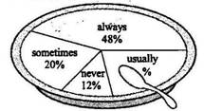
( )34．Breakfast is the most important meal of a day．The picture shows how often 200 students in a school eat breakfast．From the information．We know the number of the students who usually eat breakfast is ______．
A．20 B．24 C．40
( )35．Which word of the following has a different stress from the others?
A．Expect． B．Dentist． C．Theater．
三、完形填空(本题共10分，每小题1分)根据短文内容选择最佳答案。
When you step into a new environment．you must have a strong wish to fit in．Fitting in means making more friends， 36 more influence(影响) on others and getting more chances to live a happier life．Here is some 37 that Call help you．
Be confident．Confidence attracts most people．Everyone is special and there is only one person like you in this world．Spend 38 thinking about your strong points．If so，you will be able to build up confidence step by step．You won’t have much difficulty fitting in．
Be kind to everyone．Kindness is the bridge to your own happiness． 39 people notice your kindness，they will return it one day．Always give more than you receive，and think more of others than of 40 ．A person who cares for others is popular everywhere．
Be active in group activities．Various activities like playing football 41 help you to be known to others．You may add more friends to your circle．At the same time，you’ll be amazed to see how much they like you． 42 wasting time being alone，go out to dance and sing together with others to develop friendship．
Be optimistic(乐观的)．Optimism makes both you and others feel pleased．It makes a good first impression(印象)．A pleasant smile costs the 43 and does the most．Humor(幽默) catches others’attention as well．People win like you for making them live 44 ．
If you follow what is mentioned above，you 45 by people around you．As a result，you will fit in very well and enjoy your new life．
( )36．A．had B．to have C．having
( )37．A．advice B．advices C．suggestions
( )38．A．sometimes B．some times C．sometime
( )39．A．Though B．When C．Until
( )40．A．you B．your C．yourself
( )41．A．can B．have to C．needn’t
( )42．A．Instead of B．As well as C．As long as
( )43．A．1ittle B．less C．1east
( )44．A．friendly B．happily C．clearly
( )45．A．will accept B．won’t accept C．will be accepted
四、阅读理解(本题共20分，每小题1分)
(A)
When we have small cuts in the skin(皮肤)，something strange may happen．The cuts are able to heal(痊愈) themselves in a couple of days．How does this happen? Read on，and you will find out the secret．
Every living thing on the earth is made up of cells(细胞)．Cells grow and make new cells．Most cells are very tiny and we can’t see them with our eyes．Different cells have different uses．Our skin cells are special ones．The cells on the surface(表面) of our skin are old dead cells．New skin cells are right under the surface．These ale the living skin cells．They do work for our bodies．They help protect our bodies and heal cuts．
Our bodies make skin cells all the time．As the old cells fall off, new cells grow in the same place．Each person makes about 1 8 kg of skin cells during his or her life．Surface skin cells fit together closely with no gaps between them．When you cut or bum yourself, you can harm your skin cells．A small cut will not do much harm．Your skin will quickly heal itself by making new skin cells．How do skin cells work? First，the cells near the cut get bigger and move into the gap．Next，these bigger cells meet in the middle．They form a new layer(层)of skin cells．Finally，new cells will grow until the gap disappears completely．In this way，your skin Can grow and get well itself．
How amazing the tiny cells ale! Next time you have a cut，don’t worry about it．Maybe in a few days，you will be surprised to find it healed．
根据短文内容选择最佳答案。
( )46．The underlined word“gaps”in the passage means“______”in Chinese．
A．突起 B．条纹 C．缝隙
( )47．From the passage，we know that cells ______．
A．are large and we Call see them with our eyes
B．can grow and make new cells
C．aren’t in most living things
( )48．Skin cells heal cuts in three steps．______ is the right order．
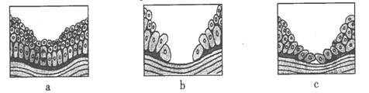
A．a→b→c B．b→c→a C．a→c→b
( )49．Which of the following is TRUE according to the passage?
A．Each person Can make 18 kg of skin cells every day．
B．Different cells have different uses in our bodies．
C．The skin cells have little work to do in the body．
( )50．The best title for this passage should be ______．
A．HOW SKIN CELLS HEAL CUTS
B．THE IMPORTANCE OF SKIN
C．HOW TO PROTECT OUR FINGERS
(B)
Hot Movies in 2010
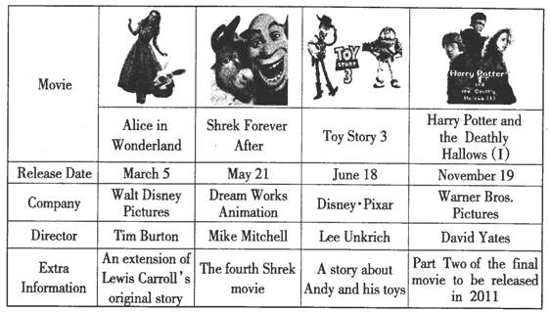
word box：release发行 animation动画制作 extension延伸 original原始的
根据表格所提供的信息选择最佳答案。
( )51．If you are a fan of Harry Potter movies，you will see the first part of the final movie on ______ at the earliest．
A．March 5 B．May21 C．November 19
( )52．The film made by Disney·Pixar is ______ according to the table above．
A．Toy Story 3 B．Harry Potter C．Shrek Forever After
( )53．______ directed Alice in Wonderland．
A．David Yates B．Mike Mitchell C．Tim Burton
( )54．From the table above, ______ movies have been released so far．
A．2 B．3 C．4
( )55．Which of the following is NOT true according to the information above?
A．Alice in Wonderland is an extension of Lewis Carroll’s original story．
B．Shrek Forever After was made by Walt Disney Pictures．
C．We Can watch Part Two of the final Harry Potter movie in 2011．
(C)
How many times have you told yourself that you can’t do something? Well，probably you can do it．
Mary was eleven years old and she had something seriously wrong with her nervous system(神经系统)．She Was not able to walk．In fact，she could hardly move．Though she believed that she had a good chance to get well again，the doctor said that few people could come back to normal after getting this disease．The little girl didn’t give up after she heard this．When she Was lying in her hospital bed，she believed that no matter what the doctors said，her going back to school was possible．
She Was sent to a health center．Every method Was tried and none worked．However，she would not give up．It seemed that nothing could beat her．The doctors all admired her and taught her to imagine that she could make it．Every day Mary would lie there，doing her mental(心理的) exercise carefully．
One day，as she Was imagining her legs moving again，it seemed as if a miracle(奇迹) happened：the bed began to move!“Look．what I’m doing! Look! I can do it! I moved!” she cried．At this moment everyone else in the hospital was frightened．They were crying，rushing for safety．And everything was falling．It was an earthquake．But Mary believed that she did it，just as she had never doubted that she would get well．And now only a few years later，she’S back in sch001．You see，to such a person who can shake the earth，such a disease is a small problem，isn’t it?
根据短文内容判断正、误。
(注意：考生将答题卡相应位置涂黑。正确的涂“A”，错误的涂“B”)
( )56．Mary Was a 12-year-old girl who was not able to move．
( )57．Though the girl was seriously ill，she believed that she would go back to school．
( )58．When Mary cried，other people in the hospital cheered for her．
( )59．The girl was strong，so she shook the earth by herself．
( )60．The story tells us that a strong belief(信念) can make a difference and that we should never give up．
(D)
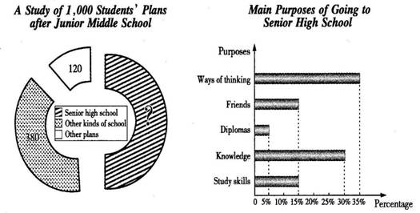
word box：junior初级的 senior高级的diploma文凭percentage百分比
根据图示所提供的信息选择最佳答案。
( )61．Of the 1，000 students，______ students plan to go to senior high school．
A．380 B．500 C．120
( )62．Ways of thinking comes ______ among the students’ main purposes of going to senior high sch001．
A．first B．third C．fifth
( )63．The number of the students who want to get study skills is the same as that of those who want to get ______ from senior high school．
A．diplomas B．friends C．ways of thinking
( )64．The students who want to get knowledge from senior high school are ______ more than those who want diplomas．
A．10％ B．20％ C．25％
( )65．Which of the following is TRUE from the information above?
A．12％of the 1，000 students have other plans after Junior middle school．
B．150 students want to make friends most in senior high school．
C．The number of the students who want to get study skills in senior high school is the smallest．
第 II 卷
五、任务性阅读(本题共10分，每空1分)
先阅读(A)、(B)两篇短文，然后根据题目要求及所给语境完成下列四项任务。
(A)
Regent’s Park is the largest grass area for sports in London．It’s also the second largest park in the city．It opens at 5:00 a.m. all the year round, but the closing time 66 , depending on the season．Regent’s Park has a lake，several public gardens，some sports grounds and three 67 playgrounds．Queen Mary’s Garden inside it is famous for 68 of beautiful roses．In the north of Regent’s Park is the London Zoo．It’s 69 than any other zoo in the world．People can play many sports in Regent’S Park，including tennis and 70 People call go boating on the main lake and enjoy a picnic in the park，too．There will be some sports events of the London Olympic Games in Regent’s Park in 2012．
(B)
Both the British and Americans speak English．However，there are several differences between American English and British English．For example，the words they use in daily life are not the same．The British call the first floor of a building the ground floor．The floor above the ground floor is the first floor，which Americans call the second floor．Once you go to Britain and America，you may notice other differences．The British usually hide their feelings．They don’t often start a talk with strangers．On the train the British often spend their time reading newspapers or books．But Americans are more active and easier to talk with．
任务l：用方框中所给词的适当形式填空，使文章通顺，连贯，合理。(每空一词，每词限用一次)
66．________ 67．________ 68．________ 69．________ 70．________
任务2：根据英文释义及首字母提示，拼写单词。
71．a________ at or to a higher point
72．h________ to stop somebody or something from being seen
任务3：同义句转换，每空一词。
However，there are several differences between American English and British English．
However，American English is 73．________ 74．________ British English in several ways．
任务4：根据短文内容简答问题。
What do the British often spend their time reading on the train?
75．_______________________________________.
六、交际应用(本题共10分，每空1分)
(A)从A—G选项中选出能填入空白处的最佳选项补全对话。(选项中有两项是多余的)
A：Hello! May I speak to Tom，please?
B：Speaking． 76
A：This is Bill．I called you yesterday，but you were not at home．
B： 77 I need to prepare something for my trip to Shanghai．
A．Who’s that?
B．I’d like to, but I’m afraid I can’t．
C．I’m buying something for my aunt．
D．Have a good trip!
E．1 was shopping at that time．
F．Who are you?
G．What did you call me for?
A：Shanghai? That’s where the World Exposition(世博会) is being held．How lucky you are!
B：So I am． 78
A：I’II have a birthday party next Friday．Would you like to come?
B： 79 My plane will take off next Wednesday．
A：What a pity(遗憾) that you can’t come! 80
B：Thank you very much．Bye!
A：Bye 1
76．________ 77．________ 78．________ 79．________ 80．________
①)填入一个适当的词补全对话，每空一词。
A：Hi, Li Yah! Have you ever been 81 the local library before?
B：You mean the one near the Dragon Tower?
A：That’s the one．
B：I go to the English Comer in the library every Saturday．A lot of English lovers practice spoken English together．Why 82 you join us?
A：Sounds great! Could you tell me how to got there?
B：The No. 7 bus will take you right there．
A：How 83 is it?
B：It’s about twenty minutes’ ride．
A： 84 is the nearest bus stop?
B：Walk along the street．and take the first turning on the left．It's opposite the post office．You can’t 85 it．
A：Thanks a lot．
B：You’re welcome．
81．________ 82．________ 83．________ 84．________ 85．________
七、阅读表达(本题共10分)
(A)阅读短文。根据短文内容完成表格，每空一词。(本题共5分，每空1分)
A small town named Bundanoon in Australia has decided to stop the sale of bottled water(瓶装水)．They say that bottled water Can cause environmental problems．Too many resources(资源) are used to make bottled water．When people finish drinking the water，the bottles will be thrown away and go into dustbins．So they require local people in the town to stop buying bottled water and use tap water to drink．Visitors are encouraged to get water from water stations in the main streets，and fill the water in bottles that can be used again．The decision has been supported(支持) by all the shopkeepers in the town．
Bundanoon is the world’s first town that has got its shops to stop selling bottled water．Probably we should follow the example．Let’S stop buying bottled water and use tap water!
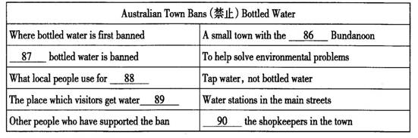
86．________ 87．________ 88．________ 89．________ 90．________
(B)根据所给中英文信息完成应用文。(本题共5分)
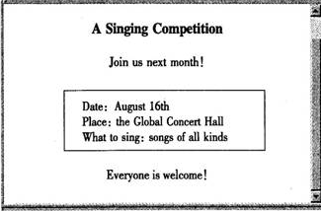
假如你是李群，在网上看到关于歌咏比赛的信息。你去找王伟，告知此事，但他没在家。请根据信息内容，用英语给王伟写一则留言，并邀请他一同参加比赛。要求包含所有信息，至少写出5句话。

________ 26th
Dear Wang Wei,
I came to tell you something important, but you were not in. _______________________
____________________________________________________________________________
____________________________________________________________________________
____________________________________________________________________________
____________________________________________________________________________
Please call me as soon as possible.
Li Qun
八、书面表达(本题共15分)
练习是学习中一个重要环节。通过英语练习，我们可以查缺补漏、拓展知识、提高成绩，但是有人认为做大量的英语练习增添负担、浪费时间、使人疲劳……请你围绕九年级学生是否应该做大量的英语练习(English exercises)这一话题展开思路谈谈你的感想。
要求：
1．请根据所提供的信息材料和话题(不要逐句翻译)，写出结构完整、条理清晰、语法准确、符合逻辑、语言丰富优美、可读性强的短文。
2．至少80词。
3．不得使用真实姓名、地名和学校名。
4．题目自拟。

___________________________________

______________________________________________________________________________

______________________________________________________________________________

______________________________________________________________________________

______________________________________________________________________________

______________________________________________________________________________

______________________________________________________________________________

______________________________________________________________________________

______________________________________________________________________________


