绝密★启用前
2011年普通高等学校招生全国统一考试(安徽卷)
英 语
本试卷分第1卷(选择题)和第II卷(非选择题)两部分，第I卷第1至第14页，第II卷第15至第16页。全卷满分150分，考试时问120分钟。
考生注意事项：
1．答题前，务必在试题卷、答题卡规定的地方填写自己的姓名、座位号，并认真核对答题卡上所粘贴的条形码中姓名、座位号与本人姓名、座位号是否一致。务必在答题卡背面规定的地方填写姓名和座位号后两位。
2．答第I卷时，每小题选出答案后，用2B铅笔把答题卡上对应题目的答案标号涂黑。如需改动，用橡皮擦干净后，再选涂其他答案标号。
3．答第II卷时，必须使用0.5毫米的黑色墨水签字笔在答题卡上书写，要求字体工整、笔迹清晰。作图题可先用铅笔在答题卡规定的位置绘出，确认后再用0.5毫米的黑色墨水签字笔描清楚。必须在题号所指示的答题区域作答，超出答题区域书写的答案无效，在试题卷、草稿纸上答题无效。
4．考试结束，务必将试题卷和答题卡一并上交。
第I卷
第一部分 听力(共两节，满分30分)
回答听力部分时，请先将答案标在试卷上。听力部分结束前，你将有两分钟的时
间将你的答案转涂到客观题答题卡上。
第一节 (共5小题；每小题1.5分，满分7.5分)
听下面5段对话。每段对话后有一个小题，从题中所给的A、B、C三个选项中选出最佳选项，并标在试卷的相应位置。听完每段对话后，你都有10秒钟的时间来回答有关小题和阅读下一小题。每段对话仅读一遍。
例：How much is the shirt?
A．￡19．15．
B．￡9．15．
C．￡9．18．
答案是B。
1. What does the man like about the play?
A. The story. B. The ending. C. The actor.
2. Which place are the speakers trying to find?
A. A hotel. B.A bank. C. A restaurant.
3. At what time will the two speakers meet?
A. 5:20. B. 5:10. C. 4:40.
4. What will the man do?
A. Change the plan. B. Wait for a phone call. C. Sort things out.
5. What does the woman want to do?
A. See a film with the man. B. Offer the man some help. C. Listen to some great music.
第二节 (共15小题：每小题1.5分，满分22.5分)
听下面5段对话。每段对话后有几个小题，从题中所给的A、B、C三个选项中选出最佳选项，并标在试卷的相应位置。听每段对话前，你将有时间阅读各个小题，每小题5秒钟；听完后，各小题给出5秒钟的作答时间。每段对话读两遍。
听第6段材料，回答第6、7题。
6. Where is Ben?
A. In the kitchen. B. At school. C. In the park.
7. What will the children do in the afternoon?
A. Help set the table. B. Have a party. C. Do their homework.
听第7段材料，回答第8、9题。
8. What are the two speakers talking about?
A. A family holiday. B. A business trip. C. A travel plan.
9. Where did Rachel go?
A. Spain. B. Italy. C. China.
听第8段材料，回答第10至12题。
10. How did the woman get to know about third-hand smoke?
A. From young smokers. B. From a newspaper article.
C. From some smoking parents.
11. Why does the man say that he should keep away from babies?
A. He has just become a father. B. He wears dirty clothes.
C. He is a smoker.
12. What does the woman suggest smoking parents should do?
A. Stop smoking altogether. B. Smoke only outside their houses.
C. Reduce dangerous matter in cigarettes.
听第9段材料，回答第13至16题。
13. Where does Michelle Ray come from?
A. A middle-sized city. B. A small town. C. A big city.
14. Which place would Michelle Ray take her visitors to for shopping?
A. The Zen Garden. B. The Highlands. C The Red River area.
15. What does Michelle Ray do for complete quiet?
A. Go camping. B. Study in a library. C. Read at home.
16. What are the speakers talking about in general?
A. Late-night shopping. B. Asian food. C. Louisville.
听第10段材料，回答第17至20题。
17. Why do some people say they never have dreams according to Dr Garfield?
A. They forget about their dreams. B. They don't want to tell the truth.
C. They have no bad experiences.
18. Why did Davis stop having dreams?
A. He got a serious heart attack. B. He was too sad about his brother's death.
C. He was frightened by a terrible dream.
19. What is Dr Garfield's opinion about dreaming?
A. It is very useful. B. It makes things worse.
C. It prevents the mind from working.
20. Why do some people turn offtheir dreams completely?
A. To sleep better. B. To recover from illnesses. C. To stay away from their problems.
第二部分 英语知识运用(共两节，满分45分)
第一节 单项填空(共15小题；每小题1分，满分15分)
从A、B、C、D四个选项中，选出可以填入空白处的最佳选项，并在答题卡上将该项涂黑。
例：It is generally considered unwise to give a child ________ he or she wants.
A. however B. whatever C. whichever D. whenever
答案是B。
21. As the story ________, the truth about the strange figure is slowly discovered.
A. begins B. happens C. ends D. develops
22. Surprisingly, Susan's beautiful hair reached below her knees and made ________ almost an overcoat for her.
A. them B. her C. itself D. herself
23. -- Oh, you sounded just like a native.
-- ________. I still have trouble expressing myself.
A. Well, not quite B. I don't care C. Yes, you're right D. I'm glad you like it
24. To be great, you must be smart, confident, and, ________, honest.
A. therefore B. above all C. however D. after all
25. Sometimes proper answers are not far to seek ________ food safety problems.
A. in B. to C. on D. after
26. -- What do you think of store shopping in the future?
-- Personally, I think it will exist along with home shopping but ________.
A. will never replace B. would never replace
C. will never be replaced D. would never be replaced
27. The factory used 65 percent of the raw materials, the rest of which ________ saved for other purposes.
A. is B. are C. was D. were
28. Whatever is left over may be put into the refrigerator, ________ it will keep for two or three weeks.
A. when B. which C. where D. while
29. -- You can have a pet dog, but suppose you get bored with it in a few days? ________?
-- We won't, we promise!
A. Then what B. All right C. How come D. So what
30. Tom asked the candy makers if they could make the chocolate easier ________ into small pieces.
A. break B. breaking C. broken D. to break
31. ________, I managed to get through the game and the pain was worth it in the end.
A. Hopefully B. Normally C. Thankfully D. Conveniently
32. -- I didn't ask for the name list. Why ________ on my desk?
-- I put it there just now in case you needed it.
A. does it land B. has it landed C. will it land D. had it landed
33. His writing is so confusing that it's difficult to make out ________ it is he is trying to express.
A. that B. how C. who D. what
34. If you ________ faults but you still want the bicycle, ask the shop assistant to reduce the price.
A. come across B. care about C. look for D. focus upon
35. -- We got here Tuesday afternoon.
-- ________ Why didn't you call us earlier?
A. Good luck! B. You did? C. It's no surprise. D. You are welcome.
第二节 完形填空(共20小题；每小题1.5分，满分30分)
阅读下面短文，从短文后各题所给的四个选项(A、B、C和D)中，选出可以填入空白处的最佳选项，并在答题卡上将该项涂黑。
When I began planning to move to Auckland to study, my mother was worried about a lack of jobs and cultural differences. Ignoring these 36 , I got there in July 2010. 37 I arrived, I realized the importance of getting a job 38 my living expenses. Determined to do this 39 , I spent several weeks going door-to-door for a job, but found 40 response (回应).
One afternoon, I walked into a building to ask 41 there were any job opportunities(机会). The people there advised continue my job search in that 42 . As I was about to 43 , a man who had been listening approached me and asked me to wait outside 44 . Nearly ten minutes later, he 45 . He asked me about my plans and encouraged me to stay 46 . Then he offered to take me to Royal Oak to 47 a job.
I was a little surprised, but had a 48 feeling about him. Along the way, I realized that I had 49 résumés (简历). Seeing this, the man 50 at his business partner's office to make me fifteen 51 copies. He also gave me some 52 on dressing and speaking. I handed out my r6sum6s and went home feeling very 53 . The following day, I received a 54 from a store in Royal Oak offering me a job.
It seems that the world always 55 to you when you need it. And this time, it was a complete stranger who turned out to be a real blessing.
36. A. doubts B. concerns C. instructions D. reasons
37. A. Even if B. Every time C. Now that D. Soon after
38. A. of B. at C. for D. with
39. A. on my own B. on my way C. by any chance D. by the day
40. any B. much C. some D. little
41. A. why B. wherever C. whether D. whenever
42. A. direction B. attitude C. language D. manner
43. A. answer B. work C. leave D. refuse
44. A. for ever B. at any time C. as usual D. for a while
45. A. returned B. hesitated C. passed D. regretted
46. A. silent B. busy C. positive D. comfortable
47. A. pick out B. search for C. take on D. give up
48. A. dull B. good C. guilty D. general
49. A. made use of B. taken care of C. run out of D. become tired of
50. A. stopped B. knocked C. glanced D. appeared
51. A. right B. more C. former D. different
52. A. pressures B. agreements C. impressions D. suggestions
53. A. lonely B. funny C. disappointed D. satisfied
54. A. call B. tip C. present D. report
55. A. turns off B. goes over C. gives back D. looks up
第三部分 阅读理解(共20小题；每小题2分，满分40分)
阅读下列短文，从每题所给的四个选项(A、B、C和D)中，选出最佳选项，并在答题卡上将该项涂黑。
A
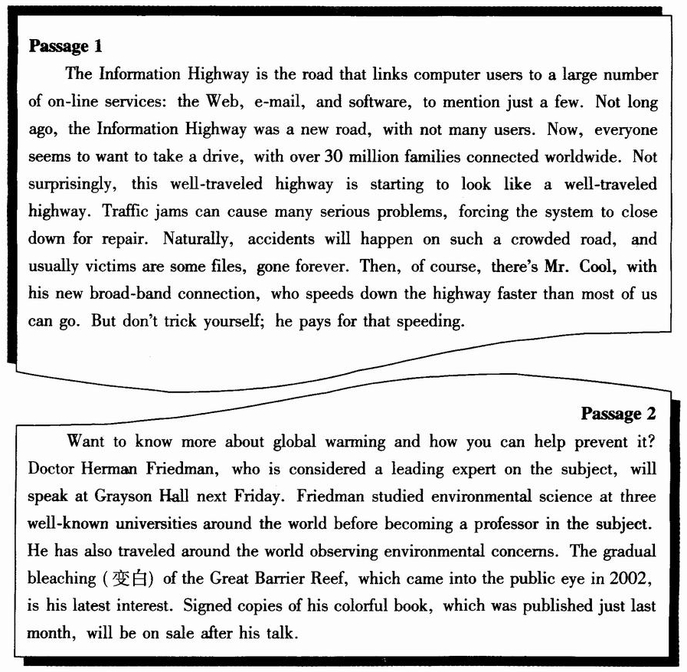

56. The Information Highway ________.
A. is free from traffic accidents B. is crowded with car drivers
C. offers just a few on-line services D. appeals to a large number of users
57. How does Mr. Cool manage to travel the Information Highway so fast?
A. By storing fewer files. B. By repairing the system.
C. By buying a better computer. D. By using a broad-band connection.
58. What can be learned from Passage 2?
A. There wil be a book show at Grayson Hall.
B. Friedman is now studying the Great Barrier Reef.
C. There will be a talk on global warming this week.
D. Friedman is a leading expert on computer science.
59. Passage 2 is most probably ________.
A. a poster about a lecture B. an ad for a new book
C. a note to a doctor in a university D. an introduction to a professor

B
Think about the different ways that peopleuse the wind. You can use it to fly a kite or to sail a boat. Wind is one of our cleanest and richest power sources (来源), as well as one of the oldest. Evidence shows that windmills (风车) began to be used in ancient Iran back in the seventh century BC. They were first introduced to Europe during the l l00s, when armies returned from the Middle East with knowledge of using wind power.
For many centuries, people used windmills to grind(磨碎) wheat into flour or pump water from deep underground. When electricity was discovered in the late 1800s, people living in remote areas began to use them to produce electricity. This allowed them to have electric lights and radio. However, by the 1940s when electricity was available to people in almost all areas of the United States, windmills were rarely used.
During the 1970s, people started becoming concerned about the pollution that is created when coal and gas are burned to produce electricity. People also realized that the supply of coal and gas would not last forever. Then, wind was rediscovered, though it means higher costs. Today, there is a global movement to supply more and more of our electricity through the use of wind.
60. From the text we know that windmills ________.
A. were invented by European armies
B. have a history of more than 2,800 years
C. used to supply power to radio in remote areas
D. have rarely been used since electricity was discovered
61. What was a new use for wind power in the late 19th century?
A. Sailing a boat. B. Producing electricity.
C. Grinding wheat into flour. D. Pumping water from underground.
62. One of the reasons wind was rediscovered in the 1970s is that ________.
A. wind power is cleaner
B. it is one of the oldest power sources
C. it was cheaper to create energy from wind
D. the supply of coal and gas failed to meet needs
63. What would the author probably discuss in the paragraph that follows?
A. The advantages of wind power.
B. The design of wind power plants.
C. The worldwide movement to save energy.
D. The global trend towards producing power from wind.

C
They are the sort of friends who are so close they trust each other with their lives. If one falls, the other is there to catch him.
They are Wellman, whose legs were permanently injured nine years ago in a rock-climbing accident, and Corbett, an experienced rock climber. Together, they climbed up Half Dome, the famous 2,000-foot rock in the Yosemite National Park, through one of the most difficult routes (路线).
During the climb, Corbett took the lead, hit in the metal spikes (尖状物) that guided the ropes and climbed up. Then, after Wellman pulled himself up the rope, Corbett went down to remove the spikes and climbed up again. This process was repeated time and again, inch by inch, for 13 days.
Wellman's job was not easy either. He got himself up the rope through upper body strength alone. In all, Wellman figured that he had done 5,000 pull-ups up the rope on the climb.
However, when the two men first met, they never talked about climbing. "He knew that was how I got injured," Wellman said. Until one day Wellman decided that he wanted to climb again and they started training.
Their climb of Half Dome was not all smooth. At one point, pieces of rock gave way, and Corbett dropped down quickly. Wellman locked their rope in place, stopping the fall at 20 feet. His quick action probably saved his friend's life.
"Your partner can save your life--you can save your partner's life, " Wellman said as the pair received congratulations from friends. "There are real close ties. "

64. Which of the following was a challenge for Corbett in climbing Half Dome?
A. To climb up to remove the spikes. B. To climb it twice.
C. To do 5,000 pull-ups up the rope. D. To lock the rope in place.
65. Why did the two men never talk about climbing when they first met?
A. Corbett was poorly trained. B. Wellman had lost interest in climbing.
C. Corbett didn't want to hurt Wellman. D. Wellman hadn't decided whether to climb again.
66. What do we know about Wellman?
A. He climbed Half Dome by himself. B. He was disabled in a traffic accident.
C. He stopped rock-climbing for some time. D. He was saved by Corbett during the climb.
67. The main idea of the text is that ________.
A. two heads are better than one B. friendship is precious in life
C. the disabled should never give up D. a man can be destroyed but cannot be defeated
D
Ireland has had a very difficult history. The problems started in the 16th century when English rulers tried to conquer(征服) Ireland. For hundreds of years, the Irish people fought against the English. Finally, in 1921, the British government was forced to give independence to the south of Ireland. The result is that today there are two "Irelands". Northern Ireland, in the north, is part of the United Kingdom. The Republic of Ireland, in the south, is an independent country.
In the 1840s the main crop, potatoes, was affected by disease and about 750, 000 people died of hunger. This, and a shortage (短缺) of work, forced many people to leave Ireland and live in the USA, the UK, Australia and Canada. As a result of these problems, the population fell from 8.2 million in 1841 to 6.6 million in 1851.
For many years, the majority of Irish people earned their living as farmers. Today, many people still work on the land but more and more people are moving to the cities to work in factories and offices. Life in the cities is very different from life in the countryside, where things move at a quieter and slower pace.
The Irish are famous for being warm-hearted and friendly. Oscar Wilde, a famous Irish writer once said that the Irish were "the greatest talkers since the Greeks". Since independence, Ireland has revived (复兴) its own culture of music, language, literature and singing. Different areas have different styles of old Irish songs which are sung without instruments. Other kinds of Irish music use many different instruments such as the violin, whistles, etc.

68. What does the author tell us in Paragraph 1?
A. How the Irish fought against the English. B. How Ireland gained independence.
C. How English rulers tried to conquer Ireland. D. How two "Irelands" came into being.
69. We learn from the text that in Ireland ________.
A. food shortages in the 1840s led to a decline in population
B. people are moving to the cities for lack of work in the countryside
C. it is harder to make a living as a farmer than as a factory worker
D. different kinds of old Irish songs are all sung with instruments
70. The last paragraph is mainly about ________.
A. the Irish character B. Irish culture
C. Irish musical instruments D. a famous Irish writer
71. What can be the best title for the text?
A. Life in Ireland B. A Very Difficult History
C. Ireland, Past and Present D. The Independence of Ireland

E
George Prochnik would like the world to put a sock in it. He makes his case in a new book, Listening for Meaning in a World of Noise. Here he explains himself (using his indoor voice):
"We've become so accustomed to noise, there's almost a deep prejudice against the idea that silence might be beneficial. If you tell someone to be quiet, you sound like an old man. But it's never been more important to find continuing quiet. Silence focuses us, improves our health, and is a key to lasting peace and satisfaction.
"We need to excite people about the sounds you start to hear if you merely quiet things down a little. During a Japanese tea ceremony, the smallest sounds become a kind of art--the spoons making a light ringing sound on a bowl, the edges of a kimono (和服) brushing against the floor.
"Deaf people are very attentive (专注的) in almost every aspect of life. If two deaf people are walking together, using.sign language, they constantly watch out for each other and protect each other by paying steady attention to the other. They are connected yet also fully aware of their surroundings. Even deaf teenagers! We in the hearing world can learn from them. If we remove the powerful blasts (一阵阵) of noise, we become aware of an extraordinarily rich world around us--of little soft sounds and the sound of footsteps, of bird songs and ice cracking (开裂声). It's astonishing how beautiful things sound when you can really listen. "

72. What does the phrase "to put a sock in it" in Paragraph 1 probably mean?
A. be quiet B. to be colorful
C. to be full of love D. to be attentive to someone
73. What does Prochnik say about us?
A. We are used to quietness. B. We have to put up with noise.
C. We do not think silence to be beneficial. D. We do not believe lasting peace to be available.
74. Which of the following is true according to Prochnik?
A. We need more sounds in our lives.
B. There is nothing to be learned from the deaf.
C. We are not aware how rich the world around us is.
D. There is too much noise at a Japanese tea ceremony.
75. It can be inferred from the text that ________.
A. we can benefit a lot from old people
B. it is a good idea to use sign language
C. there is no escape from the world of sound
D. it is possible to find how beautiful things sound

第Ⅱ卷
考生注意事项：
请用0.5毫米黑色墨水签字笔在答题卡上作答，在试题卷上答题无效。
第四部分写作(共两节，满分35分)
第一节 任务型读写(共10小题；每小题1分，满分10分)
阅读下面短文，根据所读内容在表格中的空白处填入恰当的单词。
注意：每个空格只填一个单词。

If we agree that the function of education is to prepare us for life, then there is very little time to waste. So, while we can, we ought to concentrate on teaching children something really useful. Here is what our schools should teach.
Politeness is a mark of civilization. The sooner children learn this, the better. In any case, a lot can be accomplished by a smile and good manners.
Like it or not, our adult lives will be consumed by the struggle for money, but we don't make an effort to teach children how to manage it. So our schools have a duty to teach them this ability from the beginning.
We're likely to accept something we are told, but that's not what educated people do. Educated people are reasonable and they look at facts. If our schools teach nothing else, they should at least teach critical (批判性的) thinking.
Children should learn to take care of their health. They should know that if they eat junk food (垃圾食品), they will become fat and unhealthy. They should be very clear about what happen to their bodies when they drink or smoke.
All of us are part of society. We have rights and responsibilities. We ought to understand what they are. We have to know a little bit of our history and geography, because we need to have an environment in which to relate to the people around us.
How will we test students on these? We can't. But that's not a reason to avoid teaching what is important. Our schools should spend every moment they have telling this to our children: "This is life, this is what you are going to face, and this is how you deal with it. "

Title | Very Useful (76) __________
Introduction | Education should be a (77) __________ for life.
Advice | Important things should be taught in (78) __________
Teaching (79) __________ | ◆How to behave (80) __________.  ◆The basic skill of (81) __________ money  ◆How to (82) __________ in a critical way  ◆How to keep (83) __________  ◆The rights and responsibilities one has in (84) __________
Conclusion | Children should be taught what (85) __________ is and how to deal with it.

第二节 书面表达(满分25分)
某校英文报开辟了一个专栏：Experience。本期话题是如何解决学习中遇到的困难。请你以“My Approach to Difficulties in Learning”为题，用英语写一篇短文，谈谈自己的一些做法。
注意：1．词数100左右；2．短文中不能出现本人相关信息。


